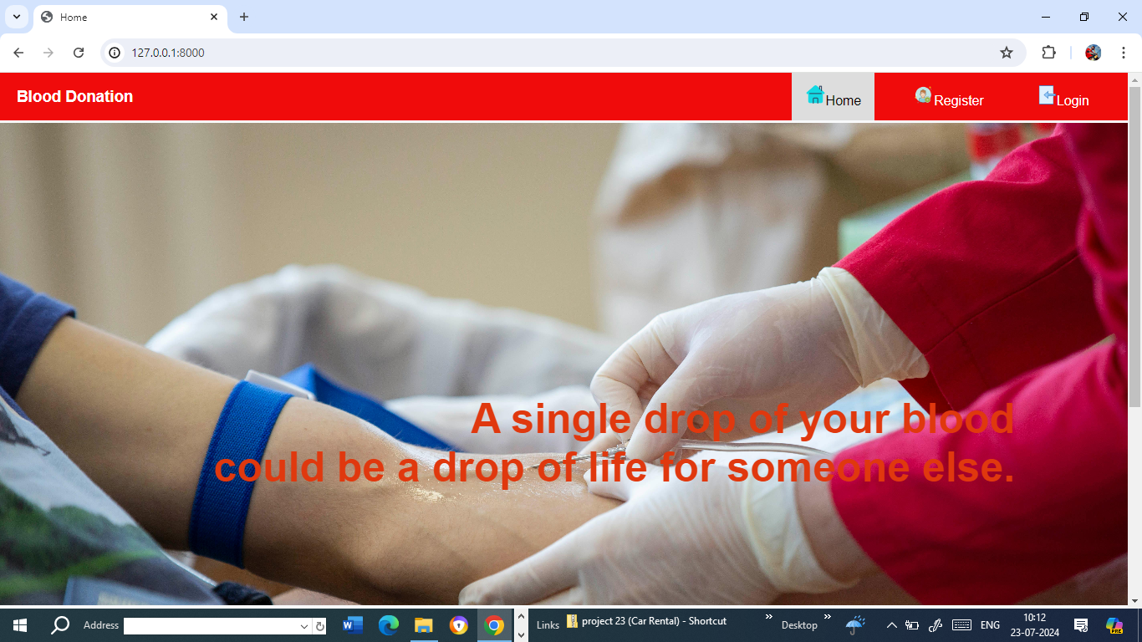
Fig 1 : Home Page
Home Page :-
The home page function in a Blood Donation web application renders the home.html template when a request is made. It takes the request object as a parameter and returns the rendered template. This function serves to display the home page of the web application. Non-authenticated users would only see "Login" and "Register" links. This approach simplifies the menu by treating all logged-in users the same, with differentiating between regular users and staff members. It ensures that all authenticated users have access to the same features, streamlining the user interface.

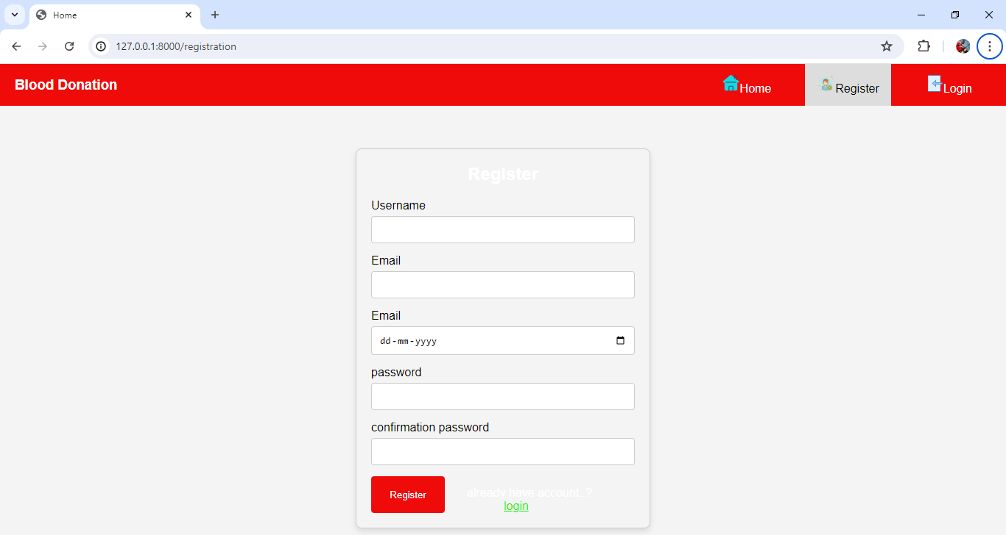
Fig 2: Registration
REGISTER :-
The register function handles user registration in a Blood Donation web application. When a POST request is made, it retrieves user details from the form, including name, email, username, password, confirmation password, and user type (admin or regular). It checks if the passwords match and whether the username already exists. If the username is unique and passwords match, a new user is created with the provided details, including setting the user as staff if selected. On success, it redirects to the login page with a success message. If there are errors, appropriate error messages are displayed, and the user is redirected back to the registration page. For GET requests, it renders the registration form.
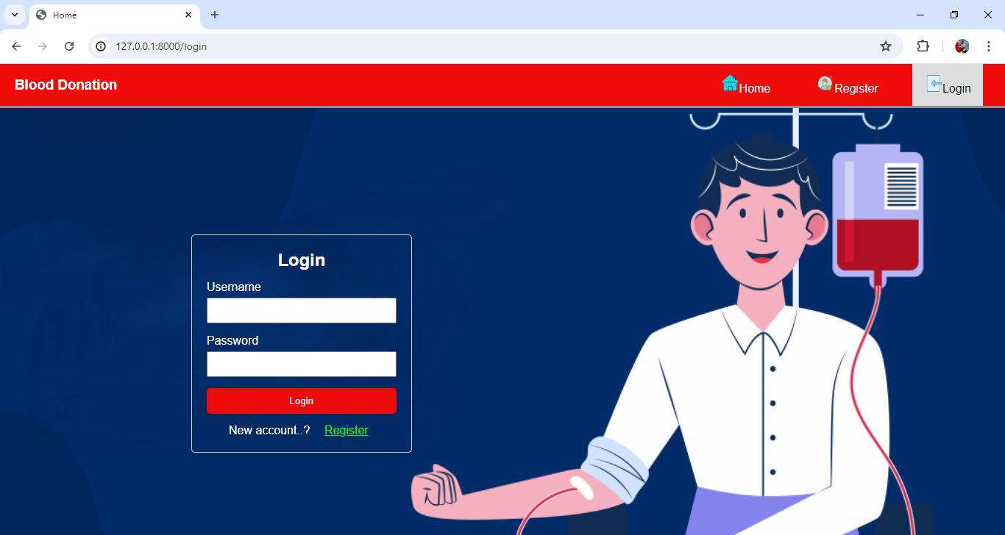
Fig 3: Login Page
LOGIN :-
The login function handles user authentication in a Blood Donation web application. It processes POST requests by retrieving the username and password, authenticates the user, and logs them in if the credentials are correct. On successful login, it redirects to the home page and shows a success message. If authentication fails, it redirects back to the login page with an error message. For GET requests, it renders the login page.
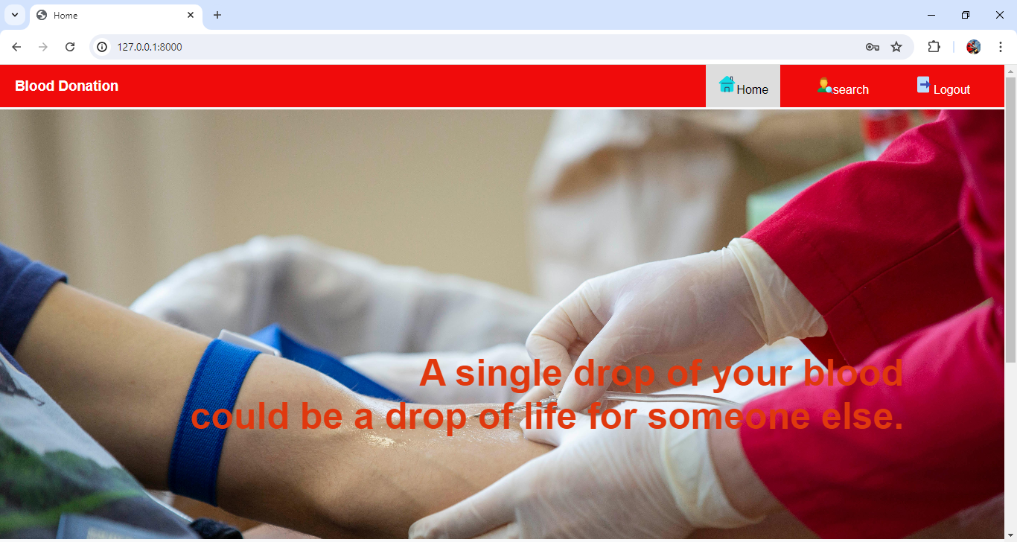
Fig 4: Admin Home Page
Admin Home Page :-
The navigation menu would display the same options for all authenticated users. Logged-in users would see links to "Home," "Search," and "Logout," regardless of their role or privileges. Non-authenticated users would only see "Login" and "Register" links. This approach simplifies the menu by treating all logged-in users the same, with differentiating between regular users and staff members. It ensures that all authenticated users have access to the same features, streamlining the user interface.
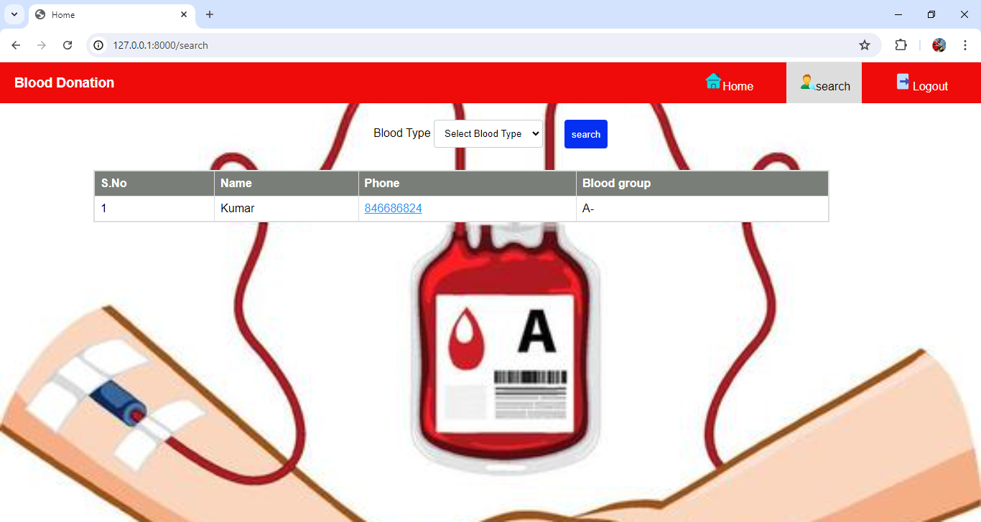
Fig 5: Search Page
The search view function handles search requests based on blood type. It first initializes a variable search to None. If the request method is POST, it retrieves the Blood type parameter from the form submission. If a blood type is provided, the function filters donar detail objects by this blood type and assigns the results to the search variable. If results are found, it renders the search template with the search results. If no results are found, it displays a "No list found" message. For GET requests or if no blood type is provided, it renders the search template with search set to None.
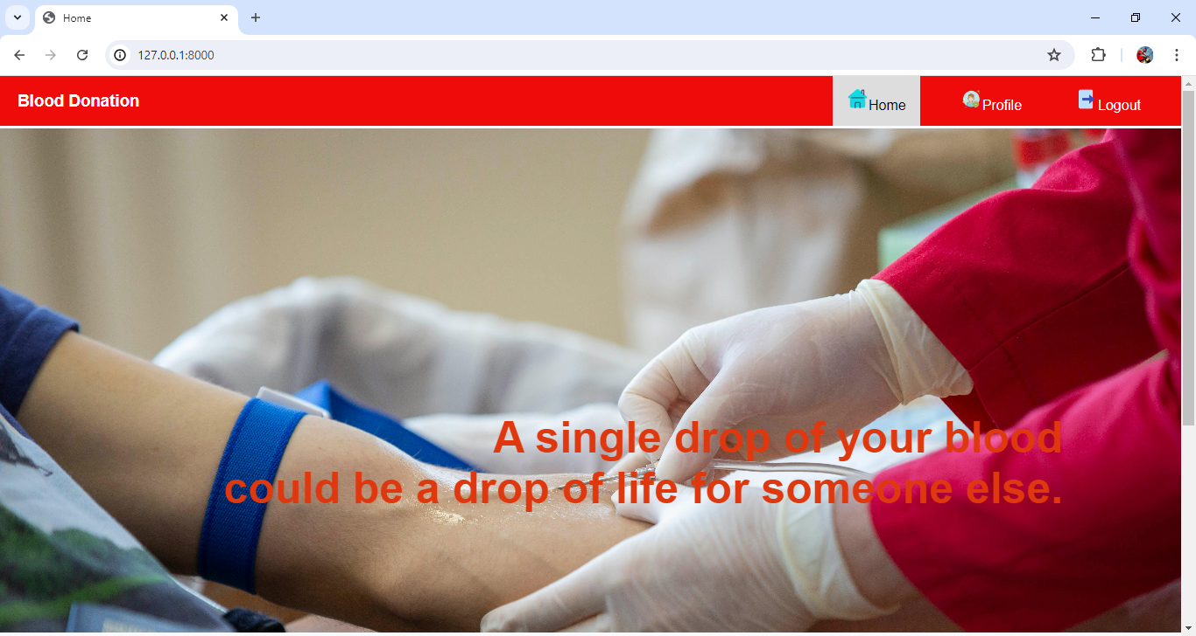
Fig 6: user Home Page
User Home Page :-
The navigation menu would display the same options for all authenticated users. Logged-in users would see links to "Home," "Profile," and "Logout," regardless of their role or privileges. Non-authenticated users would only see "Login" and "Register" links. This approach simplifies the menu by treating all logged-in users the same, with differentiating between regular users and staff members. It ensures that all authenticated users have access to the same features, streamlining the user interface.
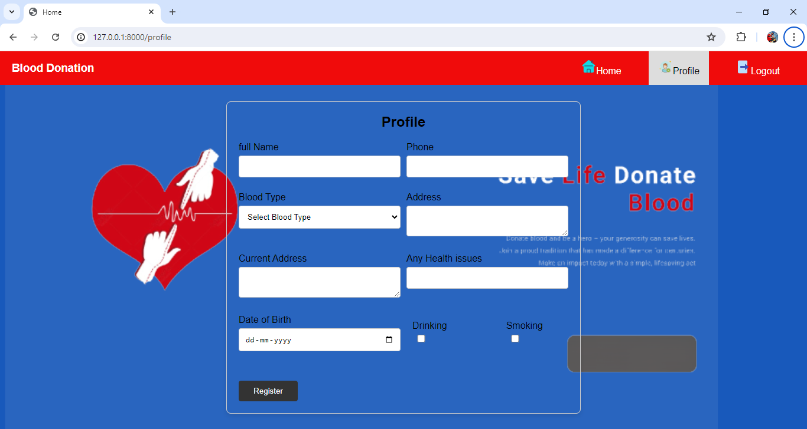
Fig 7:Profile Page
The profile view function first checks if the logged-in user has an associated donar detail object using hasattr. If the user has a profile, it retrieves this profile and renders the profile template with the profile data. If the user does not have a profile and the request method is POST, the function collects various profile details (such as name, phone number, blood type, and health issues) from the form submission. It also checks for boolean fields like drinking and smoking based on form input. A new donar detail object is created and saved with the provided information. After successfully creating the profile, the user is redirected to the profile page. For GET requests or if no form data is submitted, it simply renders the profile template without any profile data.

